EEI6373 – Performance Modelling

Mini Project Deliverable
Supermarket Cashier Checkout System ( Performance Analysis )

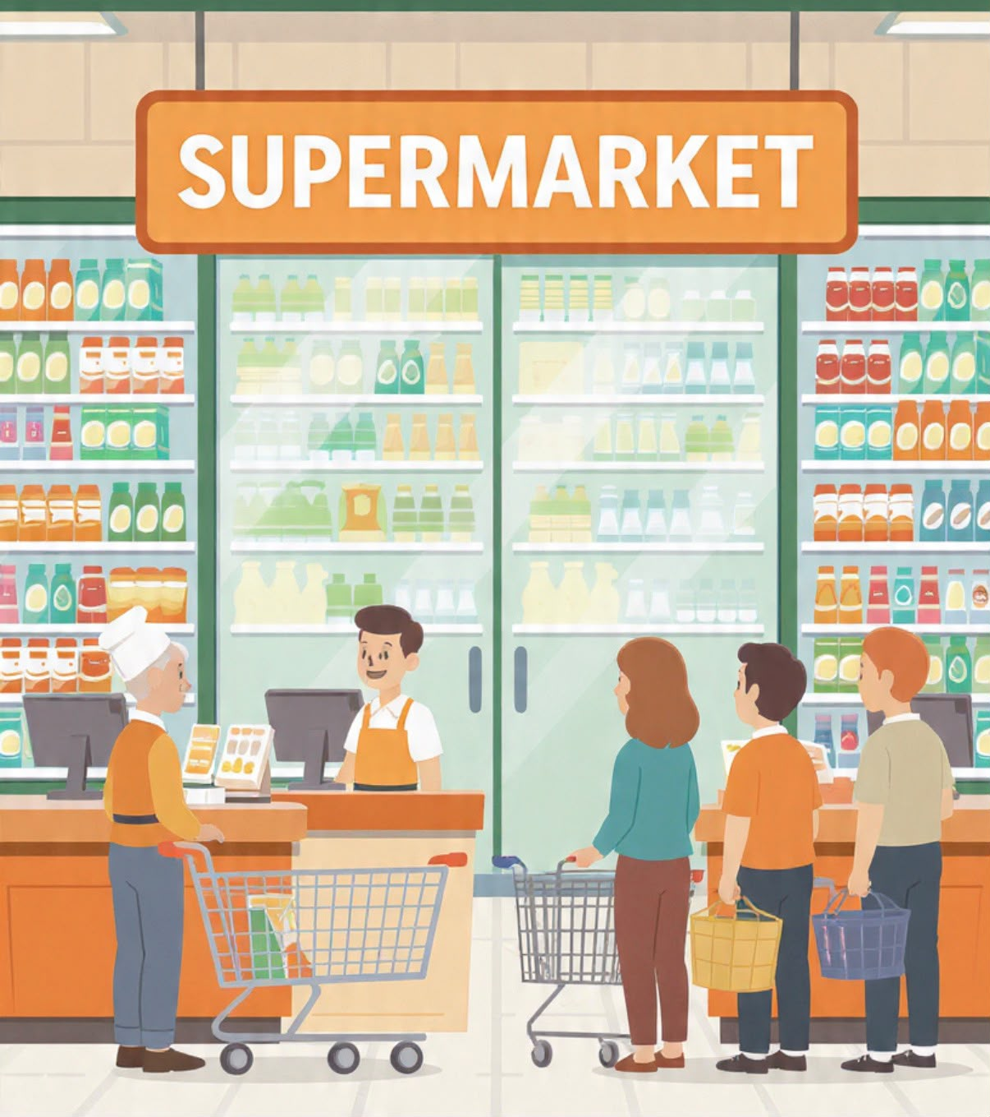

Name - L.A.M.C.H.Karunasena
- Number - s22010004
Reg.Number - 422510839

1. Identify a Complex System

Selected System: Supermarket Cashier Checkout System
A supermarket cashier checkout system is a common service-based queuing system where customers join checkout queues after finishing their shopping. The system includes several checkout counters, with each counter being managed by a cashier who serves customers one at a time according to their arrival order.
This system can be considered a complex system because customer arrivals and service times are not always predictable. The number of customers entering the checkout area can change depending on factors such as the time of day, weekends, holidays, and special promotions. Additionally, the time required to serve each customer varies based on the number of items purchased, the payment method used, and the cashier’s working speed.
During busy time periods, such as evenings or weekends, the number of customers arriving may be higher than the available checkout capacity. This can lead to longer queues, increased customer waiting times and reduced service efficiency. On the other hand, during less busy periods, some checkout counters may remain unused, resulting in inefficient use of available resources.
The performance of this system can be evaluated using measurable factors such as customer waiting time, queue length, customer service rate, and cashier utilization. By applying techniques such as Queuing Theory and Discrete Event Simulation, the behavior of the checkout system can be analyzed, possible bottlenecks can be identified, and improvements can be suggested to provide better service and resource management.

- High Level Problem Description

In a supermarket environment, long waiting lines and slow checkout processes are common problems that can negatively affect customer satisfaction and overall business performance. When a large number of customers arrive at the same time, checkout queues become longer, increasing customer waiting times and potentially causing some customers to leave without completing their purchases. However, having too many cashiers available during low-demand periods can result in unnecessary labor costs and poor resource utilization.
The main objective is to identify the right balance between the number of cashiers and customer demand. The system should provide a smooth checkout experience for customers while ensuring that available resources are used effectively.
To evaluate the performance of the checkout system, a simulation model will be created using different customer arrival patterns and service times. The system behavior will be tested under several scenarios, including:
- Normal customer flow (baseline scenario) - Represents the usual operating condition of the supermarket with average customer arrivals and service times.
- High customer traffic (peak hours) - Simulates busy periods by increasing the customer arrival rate to observe the impact on queue length and waiting time.
- Increasing the number of cashiers - Evaluates how adding more checkout counters can improve service efficiency and reduce customer delays.
- Improving service speed - Examines the effect of reducing customer service time on overall system performance.
By comparing the results from these different scenarios, the performance of the checkout system can be analyzed, bottlenecks can be identified, and suitable improvements can be recommended to achieve better customer service and efficient resource utilization.

- Performance Objectives

This project's primary goal is to analyze customer flow, wait times, and cashier utilization in order to evaluate and enhance the supermarket cashier checkout system's performance.
The key objectives are:
- Reduce Customer Waiting Time -Analyze queue delays and find ways to provide faster checkout services.
- Increase System Throughput - Measure the number of customers served within a given time and improve service capacity.
- Identify Performance Issues - Detect bottlenecks caused by high customer arrivals and limited cashier capacity.
- Optimize Cashier Utilization - Determine the appropriate number of cashiers needed for efficient operation.
- Analyze Queue Behavior - Study changes in queue length under different customer flow conditions.
- Compare Different Scenarios - Evaluate normal hours, peak hours, and additional cashier scenarios to find the best setup.
- Balance Service Quality and Cost - Maintain customer satisfaction while avoiding unnecessary resource usage.

- Data Set
Analysis Dataset
A customer-level dataset containing 50 records was prepared to represent supermarket checkout activities. The data set includes Customer ID, Arrival Time, Number of Items, Service Time, and Cashier ID. These attributes represent customer arrivals, shopping load, checkout service requirements and cashier allocation.
Sample
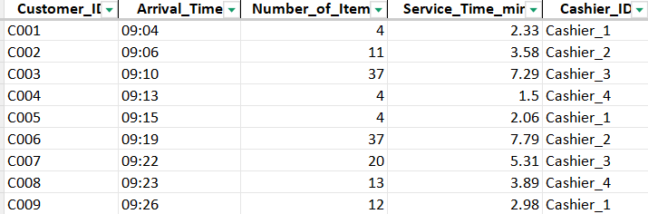
GitHub LInk - https://github.com/ChanuHasintha/Performance-Modelling-MP/blob/main/supermarket_checkout_analysis_dataset.xlsx
Simulation Dataset
Different customer loads were tested while varying the number of cashiers. The simulation generated a performance dataset containing Customers, Cashiers, Average Wait, Throughput, Average Queue and Utilization.
Sample
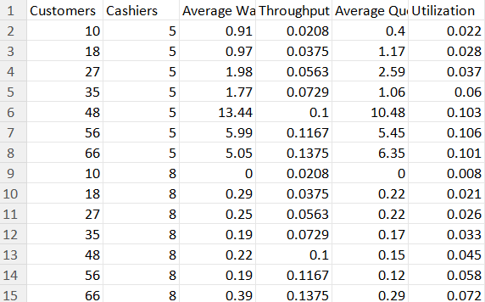
GitHub Link - https://github.com/ChanuHasintha/Performance-Modelling-MP/blob/main/supermarket_results.csv

GitHub Repositories Link - https://github.com/ChanuHasintha/Performance-Modelling-MP.git
GitHub Document Link - https://github.com/ChanuHasintha/Performance-Modelling-MP/blob/main/422510839_Performance%20Modelling_Deliverable.docx

